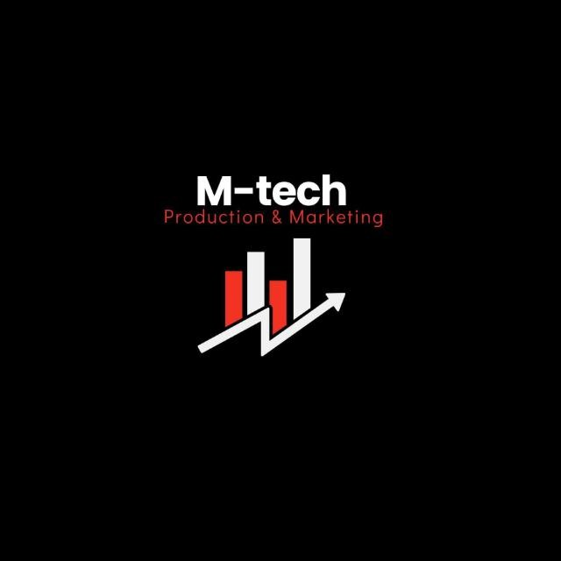

M-Tech Production & Marketing
Technology | Training | Marketing | Projects
TASK 5 REPORT
Internship Program — Batch 2026

Submitted By:
Hamza Badshah / Mtech-AI26028
Department:
AI / ML
Submitted To:
Ma’am Fatima
_______________________ | Supervisor:

Date:
08 July 2026
Haripur Main Bazar, Khyber Pakhtunkhwa, Pakistan
mtechproductionandmarketing@gmail.com | +92 336 2222480

Introduction

This report presents the work completed for Task 05 of the M-Tech Production & Marketing AI/ML
Internship Program, Batch 2026. The internship focuses on practical exposure to core concepts in Artificial Intelligence and Machine Learning, equipping interns with skills applicable to real-world technology and marketing challenges.
M-Tech Production & Marketing is a forward-looking company based in Haripur, KPK, specializing in Technology, Training, Marketing, and Projects. The internship is structured in a 9-Phase roadmap designed to progressively build theoretical knowledge and hands-on project experience.

Objectives

- To understand the concept of supervised learning.
- To learn the difference between regression and classification.
- To study common supervised learning algorithms and their applications.
- To understand how supervised learning models are trained and evaluated.

Task Description

The assigned task was to study supervised learning and its two major categories: regression and classification. This included understanding how labeled datasets are used to train machine learning models, the differences between predicting continuous and categorical values, and the practical applications of each approach.

Work Done

During this experiment, I completed the following activities:
- Studied the fundamentals of supervised learning and how it works with labeled data.
- Learned the difference between regression and classification problems.
- Explored regression models used to predict continuous numerical values.
- Studied classification models used to predict categorical outcomes.
- Understood the process of training supervised learning models using labeled datasets.
- Learned how trained models are tested and evaluated for prediction accuracy.
- Reviewed real-world applications of regression and classification in machine learning.
- Strengthened my understanding of selecting the appropriate supervised learning technique based on the problem type.

Challenges Faced

- Understanding the difference between regression and classification required careful study.
- Learning when to use each supervised learning technique was initially challenging.
- Relating theoretical concepts to practical applications required additional practice.

Key Learnings

- Learned the fundamentals of supervised learning.
- Understood the differences between regression and classification models.
- Gained knowledge of how labeled data is used for model training.
- Learned the importance of evaluating model performance before deployment.
- Improved my understanding of real-world supervised learning applications.

Conclusion

This experiment strengthened my understanding of supervised learning and its two primary approaches: regression and classification. I learned how labeled data is used to train predictive models and gained insight into selecting the appropriate technique for different types of machine learning problems. The knowledge gained from this experiment provides a strong foundation for implementing supervised learning algorithms in future practical tasks.

Intern Signature: | ____Hamza Badshah____ | Supervisor: | _______________________
Name: | Hamza Badshah | Name:
Date: | 08 July 2026 | Designation:

